WEEK 4: PREDICTIVE MODELING AND OPTIMIZATION IN LOGISTICS SYSTEMS
Virtual Logistics Data Analyst Internship – Final Week Report

1. Introduction and Problem Definition
The objective of Week 4 is to apply predictive modeling and optimization concepts to a logistics problem. The selected prediction problem is forecasting delivery time in days for individual shipments. Accurate delivery-time predictions can support customer communication, resource planning, route management, and early identification of shipments that may experience operational delays.

2. Dataset and Target Variable
A hypothetical logistics dataset containing 600 shipment records was simulated using Python. The dataset contains operational variables representing shipment characteristics and transportation conditions. The target variable is delivery_time_days, which represents the predicted duration required to complete a shipment.
- region – Operational region of the shipment.
- transport_mode – Road, Rail, or Air.
- shipment_volume – Relative volume of the shipment.
- distance_km – Distance travelled by the shipment.
- transport_cost – Estimated transportation cost.
- delivery_time_days – Target variable representing delivery duration.

3. Model Selection
Two regression models were selected and compared. Linear Regression was used as a simple baseline because it is easy to interpret and can identify linear relationships between logistics variables and delivery time. Random Forest Regressor was selected as a more advanced ensemble model because it can capture non-linear relationships and interactions between variables without requiring a strict linear assumption.

4. Data Preparation and Training
The dataset was divided into training and testing sets using an 80:20 split. Numerical variables were prepared using median imputation, while categorical variables were encoded using one-hot encoding. A pipeline was used so that the same preprocessing process was applied consistently during training and prediction.
X_train, X_test, y_train, y_test = train_test_split(
X, y, test_size=0.20, random_state=42
)
preprocessor = ColumnTransformer([
("num", SimpleImputer(strategy="median"), numerical_features),
("cat", OneHotEncoder(handle_unknown="ignore"), categorical_features)
])

5. Evaluation and Validation
The models were evaluated using Mean Absolute Error (MAE), Root Mean Squared Error (RMSE), and R-squared (R²). MAE measures the average absolute prediction error, RMSE gives additional importance to larger errors, and R² indicates how much variation in delivery time is explained by the model. Five-fold cross-validation was also used to estimate whether the model performance remains reasonably stable across different data splits.
Model | MAE | RMSE | R² | Mean CV R²
Linear Regression | 0.7770 | 0.9733 | 0.7610 | 0.7686
Random Forest Regressor | 0.8326 | 1.0627 | 0.7151 | 0.7492
Based on the lowest RMSE, the selected model for this simulated dataset is Linear Regression. It achieved an MAE of 0.7770 days, an RMSE of 0.9733 days, and an R² value of 0.7610 on the test data.

6. Visualization: Actual vs Predicted Delivery Time
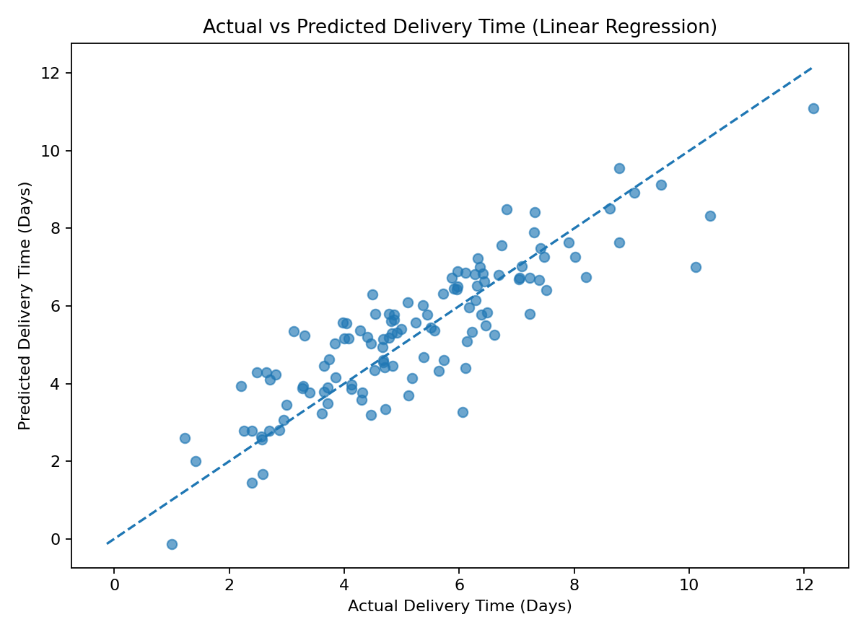
This visualization compares actual delivery times with the model predictions. Points closer to the reference line indicate more accurate predictions. The chart provides an intuitive way to identify whether the model systematically overpredicts or underpredicts delivery duration.

7. Visualization: Model Comparison
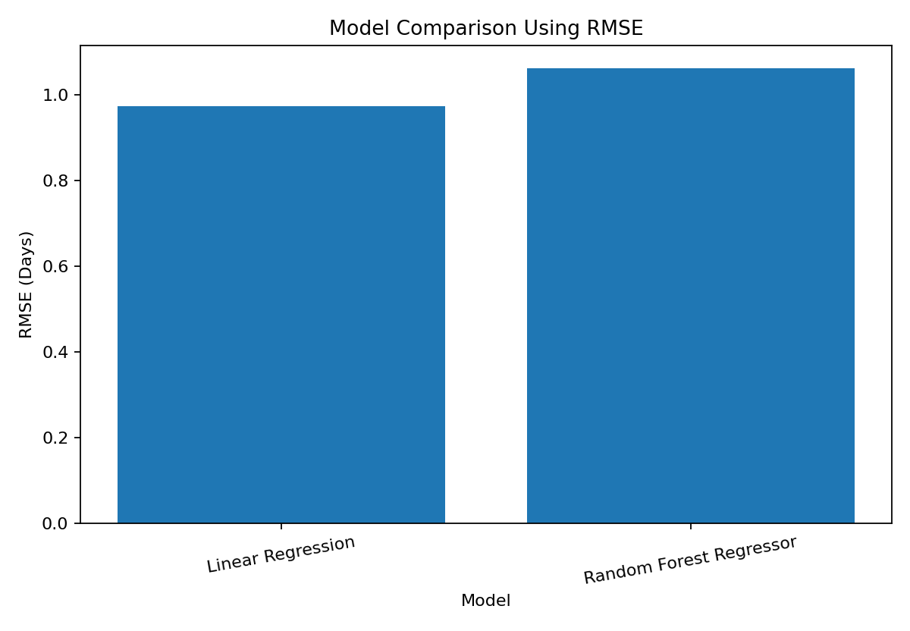
The model comparison chart uses RMSE because it highlights larger prediction errors. Comparing the baseline and ensemble approach helps justify model selection rather than choosing a model without performance evidence.

8. Optimization Strategy
Prediction alone does not improve logistics operations unless the predictions are translated into actions. The predictive model was therefore used to identify shipments with relatively high predicted delivery times. In the simulated dataset, 150 shipments were classified as high-risk based on the upper range of predicted delivery time.
- Resource Allocation: Allocate additional drivers, vehicles, or handling capacity to high-risk shipments and regions.
- Route Planning: Review long-distance routes with consistently high predicted delivery times and consider alternative routing or transport modes.
- Early Intervention: Use predicted delivery time as an alert system before a shipment is completed, allowing managers to take corrective action.
- Cost Optimization: Compare transportation cost per kilometre across routes and modes to identify expensive operations.
- Capacity Planning: Use delivery-time forecasts together with shipment volume to anticipate future operational workload.

9. Predicted Delivery Time by Transport Mode
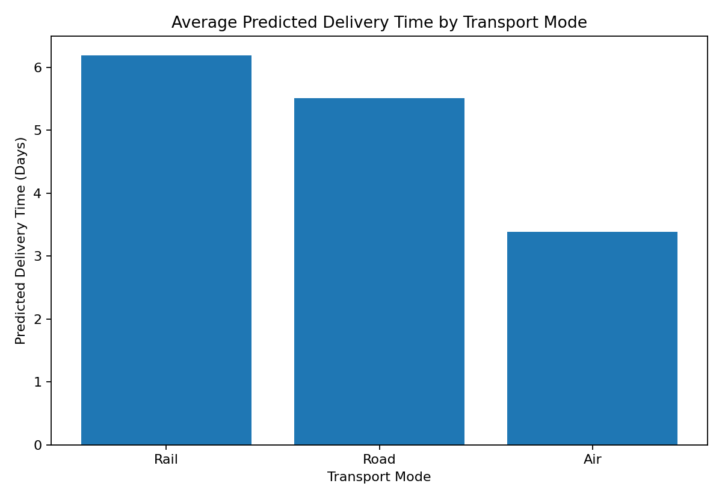
This visualization supports optimization decisions by comparing predicted delivery duration across transport modes. A transport mode with a higher average predicted delivery time may require closer operational monitoring, especially when service-level requirements are strict.

10. Key Recommendations
- Deploy the selected predictive model as a decision-support tool rather than relying only on historical averages.
- Monitor MAE and RMSE over time because model performance may change when operational conditions change.
- Investigate shipments with high predicted delivery times before they become delayed.
- Combine predicted delivery risk with transportation cost to prioritize interventions that provide the highest operational benefit.
- In a real-world implementation, enrich the dataset with traffic, weather, warehouse processing time, driver availability, and route information.
- Periodically retrain and validate the model as new logistics data becomes available.

11. Python Code Excerpts
from sklearn.ensemble import RandomForestRegressor
from sklearn.metrics import mean_absolute_error, mean_squared_error, r2_score
model = RandomForestRegressor(n_estimators=150, random_state=42)
model.fit(X_train_processed, y_train)
predictions = model.predict(X_test_processed)
mae = mean_absolute_error(y_test, predictions)
rmse = mean_squared_error(y_test, predictions) ** 0.5
r2 = r2_score(y_test, predictions)
cv_scores = cross_val_score(
model, X_processed, y,
cv=5,
scoring="r2"
)

12. Conclusion
Week 4 demonstrates how predictive modeling can be integrated into logistics analytics. A delivery-time forecasting problem was defined, two regression approaches were compared, and performance was evaluated using MAE, RMSE, R², and cross-validation. The selected model was then connected to practical optimization strategies including high-risk shipment identification, resource allocation, route improvement, and cost monitoring. The project shows how historical logistics variables can be transformed into predictive insights that support proactive and data-driven decision-making.

